1. **Explain the four Vs of Big Data.**

The four Vs of Big Data are:

**Volume:**

Volume refers to the sheer size of the data. Big Data typically involves massive amounts of information that exceed the capacity of traditional data processing systems. This can range from terabytes to petabytes and beyond. The ability to handle and store such large volumes of data is a fundamental aspect of Big Data.

**Velocity:**

Velocity represents the speed at which data is generated, collected, and processed. With the advent of technologies like the Internet of Things (IoT), social media, and online transactions, data is being produced at an incredibly rapid pace. Real-time or near-real-time data processing is often required to make timely decisions based on this incoming data.

**Variety:**

Variety pertains to the diverse types of data that can be encountered in the Big Data landscape. This includes structured data (e.g., data stored in relational databases), semi-structured data (e.g., XML or JSON files), and unstructured data (e.g., text, images, audio, video). Dealing with a wide range of data formats and sources can be challenging, as each may require different processing techniques.

**Veracity:**

Veracity relates to the accuracy and reliability of the data. Big Data can be messy and contain errors, inconsistencies, and uncertainties. Ensuring the quality of the data is essential, as unreliable data can lead to incorrect analyses and decisions. Data cleansing and quality assurance processes are crucial to address veracity issues.

1. **Explain the various sources of Big Data.**

**Machine-generated data**:

These include medical devices, GPS data, data of usage statistics captured by servers and applications and the huge amount of data that usually move through trading platforms, to name a few.

**Human-generated structured data:**

It mainly includes all the data a human input into a computer, such as his name and other personal details. When a person clicks a link on the internet, or even makes a move in a game, data is created- this can be used by companies to figure out their customer behavior and make the appropriate decisions and modifications.

**Captured data:**

It is passively based on user’s behavior. For instance, if someone types something on the search bar through Google, it is captured at the moment to have basic research on what’s on trend and case studies in future. Another example could be the GPS via smartphone that captures each moment someone searches for something and gets a real-time output.

**User-generated data:**

It is kind of unstructured data which is put on internet each and every moment by the users themselves. For instance, the Likes, Shares, Tweets, Re-tweets, Comments, on Facebook posts/photos/videos, YouTube, Twitter, etc. are all user-generated.

1. **Explain the various types of analytics in Big Data.**

There are different types of analytics, they are:

**a. Descriptive Analytics:**

Descriptive analytics is the foundational level of data analysis and focuses on summarizing and presenting historical data to provide an understanding of what has happened in the past. It aims to answer questions like "What happened?" or "What are the key trends and patterns in our data?" This stage often involves generating reports, charts, and dashboards to visualize data, enabling stakeholders to gain insights into historical performance. Descriptive analytics is essential for understanding the current state of an organization and identifying areas that may require further analysis or action. In the context of big data, this involves processing and summarizing massive datasets to make them more understandable.

**b. Diagnostic Analytics:**

Diagnostic analytics goes beyond descriptive analytics by seeking to understand the reasons behind past events or trends. It delves into the "Why did it happen?" question by identifying the root causes of specific outcomes or anomalies in the data. Diagnostic analytics often involves the use of statistical methods and data exploration techniques to uncover correlations, relationships, and potential factors contributing to observed patterns. It helps organizations identify areas for improvement and informs decision-makers about the factors that influence their data.

**c. Predictive Analytics:**

Predictive analytics leverages historical data and statistical or machine learning models to make predictions about future events or outcomes. It answers questions like "What is likely to happen in the future?" By analyzing large datasets, organizations can develop models that can forecast trends, patterns, or specific outcomes. These models can be used for a wide range of applications, such as demand forecasting, customer churn prediction, and fraud detection. Predictive analytics enables organizations to be proactive and make informed decisions to capitalize on opportunities or mitigate potential risks.

**d. Prescriptive Analytics:**

Prescriptive analytics is the highest level of data analysis and decision-making, and it focuses on providing actionable recommendations based on predictive models and business objectives. It answers questions like "What should we do to achieve a desired outcome?" or "What is the best course of action to optimize a process?" Prescriptive analytics not only predicts future outcomes but also suggests specific actions or strategies to maximize desired results. It considers various constraints, goals, and business rules to recommend the most suitable actions, taking into account multiple possible scenarios.

1. **Explain the classification of Big Data.**

**a. Structured data**

Structured data is highly organized and follows a specific format or schema. It is typically found in relational databases and consists of rows and columns, making it easy to query and analyze. Examples of structured data include financial records, customer information, and transaction data. There are two sources of structured data:

* **Machine-generated data:** All the data received from sensors, web logs and financial systems are classified under machine-generated data. These include medical devices, GPS data, data of usage statistics captured by servers and applications and the huge amount of data that usually move through trading platforms, to name a few.
* **Human-generated:** structured data mainly includes all the data a human input in to a computer, such as his name and other personal details. When a person clicks a link on the internet, or even makes a move in a game, data is created- this can be used by companies to figure out their customer behavior and make the appropriate decisions and modifications.

**b. Unstructured data**

Unstructured data lacks a specific structure and format. It can take various forms, such as text, images, audio, and video. Examples of unstructured data include social media posts, emails, multimedia content, and sensor data. Analyzing unstructured data often requires natural language processing (NLP), image recognition, and other techniques to extract meaning from the content. they have no clear format in storage.

The Unstructured data is further divided into:

* **Captured data** is passively based on user’s behavior. For instance, if someone types something on the search bar through Google, it captures each moment someone searches for something and gets a real-time output.
* **User-generated data** is that kind of unstructured data which is put on internet each and every moment by the users themselves. For instance, the Likes, Shares, Tweets, Re-tweets, Comments, on Facebook posts/photos/videos, YouTube, Twitter, etc. are all user-generated.

**c. Semi-structured data.**

Semi-structured data falls somewhere between structured and unstructured data. It has some level of structure, typically in the form of tags, labels, or hierarchies, but does not adhere to a rigid schema. Common examples of semi-structured data include XML files, JSON data, and NoSQL databases.

1. **Explain the applications of Big Data.**

**Retail and E-Commerce:** Big Data is used for customer behavior analysis, personalized product recommendations, inventory management, and demand forecasting. Retailers use it to optimize pricing strategies and enhance the overall shopping experience.

**Marketing and Advertising:** Marketers utilize Big Data to analyze customer demographics, preferences, and engagement with advertising campaigns. This information helps in targeting ads more effectively and measuring their impact.

**Telecommunications:** Telecommunication companies use Big Data for network optimization, fraud detection, and customer churn prediction. It helps in ensuring network reliability and improving customer satisfaction.

**Energy and Utilities:** Big Data is applied in the energy sector for smart grid management, energy consumption optimization, and predictive maintenance of utility infrastructure. This leads to more efficient energy distribution and reduced downtime.

**Transportation and Logistics**: Big Data is instrumental in optimizing routes, reducing fuel consumption, and enhancing logistics operations. It's used in tracking shipments, managing fleets, and improving the overall supply chain efficiency.

**Education:** Educational institutions leverage Big Data to improve student performance through personalized learning experiences. Analyzing student data helps in identifying at-risk students and tailoring educational resources accordingly.

**Environmental Science:** Big Data aids in climate modeling, environmental monitoring, and natural disaster prediction. Researchers analyze data from satellites, weather stations, and sensors to better understand and address environmental challenges.

**Sports Analytics:** Big Data is used in sports for player performance analysis, injury prevention, and game strategy optimization. It provides insights into athlete metrics, game statistics, and fan engagement.

1. **Explain the various elements of Big Data Stack with a neat diagram.**

The big data stack comprises of the following elements. They are:

1. Raw data sources
2. Data Access Connectors
3. Data Storage
4. Batch Analytics
5. Real time Analytics
6. Interactive Querying
7. Serving Databases, Web & Visualization Framework

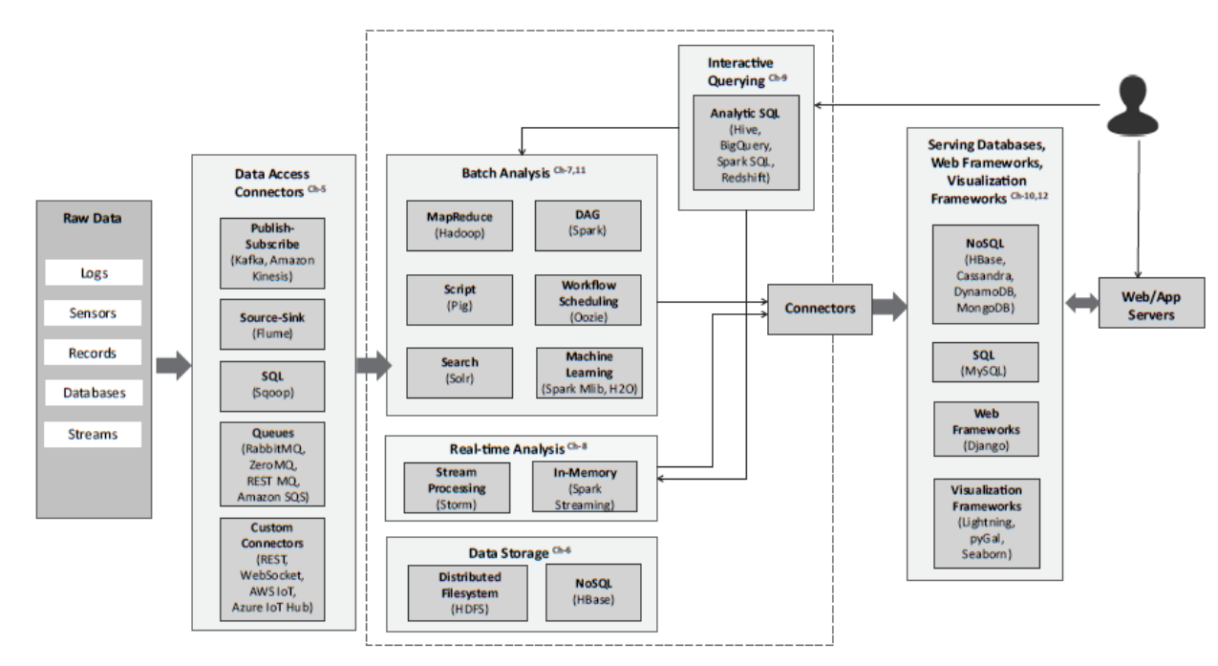

1. **Raw data sources**

These are the origins of the data, which can include a wide variety of sources such as social media, sensors, log files, databases, and more. Raw data sources provide the initial data that is ingested into the Big Data stack. Some of the examples of raw big data sources include:

* **Logs:** Logs generated by web applications and servers which can be used for performance monitoring
* **Transactional Data:** Transactional data generated by applications such as eCommerce, Banking and Financial
* **Social Media:** Data generated by social media platforms
* **Databases:** Structured data residing in relational databases
* **Clickstream Data:** Clickstream data generated by web applications which can be used to analyze browsing patterns of the users
* **Surveillance Data:** Sensor, image and video data generated by surveillance systems
* **Healthcare Data:** Healthcare data generated by Electronic Health Record (EHR) and other healthcare applications
* **Network Data:** Network data generated by network devices such as routers and firewalls

1. **Data Access Connectors**

Data access connectors or data ingestion components are responsible for collecting and bringing in data from various sources into the Big Data environment. These connectors ensure that data is efficiently and securely transferred from raw data sources to the data storage and processing layers.

* **Publish-Subscribe Messaging:** Publish-Subscribe is a communication model that involves publishers, brokers and consumers. Publishers are the source of data. Publishers send the data to the topics which are managed by the broker.
* **Database Connectors:** Database connectors can be used for importing data from relational database management systems into big data storage and analytics frameworks for analysis.
* **Messaging Queues:** Messaging queues are useful for push-pull messaging where the producers push data to the queues and the consumers pull the data from the queues. The producers and consumers do not need to be aware of each other.

1. **Data Storage**

Data storage is where the ingested data is stored for further processing and analysis. It can include components like data lakes for storing raw and unstructured data and databases optimized for structured data storage. Common technologies include Hadoop Distributed File System (HDFS) for data lakes and relational databases for structured data.

1. **Batch Analytics**

Batch analytics involves analyzing data in large, periodic batches. This approach is often used for historical analysis and processing vast amounts of data efficiently. Hadoop MapReduce and Apache Spark are commonly used for batch processing. These include the following:

* **Hadoop-MapReduce:** Hadoop is a framework for distributed batch processing of big data. The MapReduce programming model is used to develop batch analysis jobs which are executed in Hadoop clusters.
* **Pig:** Pig is a high-level data processing language which makes it easy for developers to write data analysis scripts which are translated into MapReduce programs by the Pig compiler.
* **Oozie:** Oozie is a workflow scheduler system that allows managing Hadoop jobs. With Oozie, you can create workflows which are a collection of actions (such as MapReduce jobs) arranged as Direct Acyclic Graphs (DAG).
* **Spark:** Apache Spark is an open-source cluster computing framework for data analytics. Spark includes various high-level tools for data analysis such as Spark Streaming for streaming jobs, Spark SQL for analysis of structured data

1. **Real time Analytics**

Real-time analytics processes data as it is generated, allowing for immediate insights and actions. Technologies like Apache Kafka, Apache Flink, and Apache Storm are used for real-time data processing and analysis. Storm can be used for real-time processing of streams of data. Storm can consume data from a variety of sources such as publish-subscribe messaging frameworks, messaging queues as RabbitMQ or ZeroMQ) and other custom connectors.

1. **Interactive Querying**

Interactive querying enables users to perform ad-hoc queries and retrieve specific data in real-time. Tools like Apache Hive and Apache Impala provide SQL-like interfaces for querying data stored in Big Data environments.

* **Spark SQL:** Spark SQL is a component of Spark which enables interactive querying. Spark SQL is useful for querying structured and semi-structured data using SQL-like queries.
* **Hive:** Apache Hive is a data warehousing framework built on top of Hadoop. Hive provides an SQL-like query language called Hive Query Language, for querying data residing in HDFS.
* **Google BigQuery:** Google BigQuery is a service for querying massive datasets. BigQuery allows querying datasets using SQL-like queries.

1. **Serving Databases, Web & Visualization Framework**

These components are responsible for serving the results of data analysis to end-users or applications. Serving databases can be used to store processed data for quick access, web frameworks provide user interfaces for data exploration, and visualization tools create charts and graphs to present insights in a human-readable format.

* **MySQL:** MySQL is one of the most widely used Relational Database Management System (RDBMS) and is a good choice to be used as a serving database for data analytics applications where the data is structured.
* **Amazon DynamoDB:** Amazon DynamoDB is a fully-managed, scalable, high-performance NoSQL database service from Amazon.
* **Cassandra:** Cassandra is a scalable, highly available, fault tolerant open source nonrelational database system.
* **MongoDB:** MongoDB is a document oriented non-relational database system. MongoDB is powerful, flexible and highly scalable database designed for web applications and is a good choice for a serving database for data analytics applications.

The following tools are used for visualization tools and frameworks:

* **Lightning:** Lightning is a framework for creating web-based interactive visualizations.
* **Pygal:** The Python Pygal library is an easy-to-use charting library which supports charts of various types.
* **Seaborn:** Seaborn is a Python visualization library for plotting attractive statistical plots.

1. **Explain the analytics flow of big data with a neat diagram.**

The analytics flow of Big Data involves a series of steps to collect, prepare, analyze, and visualize data to derive meaningful insights.

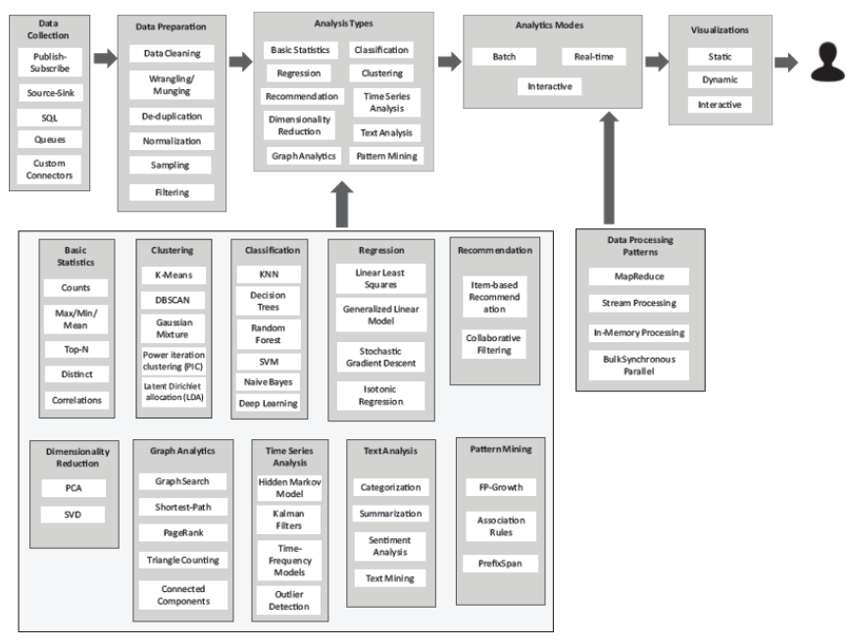

1. **Data Collection**

* Data collection is the initial step where data is gathered from various sources. These sources can include structured databases, unstructured text, sensor data, social media, logs, and more.
* The collected data can be raw and may come from disparate sources, which is typical in Big Data scenarios. Data collection methods may involve data ingestion, ETL (Extract, Transform, Load) processes, and real-time data streaming.

1. **Data Preparation**

* Data preparation is crucial to ensure that the data is clean, complete, and well-structured for analysis. It involves several sub-steps like Data Cleaning, Data Integration, Data Transformation, Data Enrichment.
* Data preparation helps ensure that the data is suitable for analysis and reduces the risk of garbage in, garbage out.

1. **Analysis Types**

Big Data analytics offers various types of analysis, including:

* **Descriptive Analytics:** Summarizing and describing historical data to understand what has happened.
* **Diagnostic Analytics:** Investigating the reasons behind specific events or trends.
* **Predictive Analytics:** Forecasting future outcomes based on historical data and patterns.
* **Prescriptive Analytics:** Providing recommendations for actions to achieve desired outcomes.

The choice of analysis type depends on the objectives of the analysis and the nature of the data.

1. **Analysis Modes**

There are two primary analysis modes:

* **Batch Processing:** Analyzing data in large, periodic batches, suitable for historical analysis and processing vast amounts of data efficiently. Technologies like Hadoop MapReduce and Apache Spark are used for batch processing.
* **Real-time Processing:** Analyzing data as it is generated, enabling immediate insights and actions. Technologies like Apache Kafka and Apache Flink are used for real-time data processing.

1. **Visualization**

* Visualization is the final step in the analytics flow and involves presenting the results of the analysis in a human-readable format. Visualization tools and techniques are used to create charts, graphs, dashboards, and reports that help stakeholders understand the insights and make informed decisions.
* Effective data visualization simplifies complex data and communicates the findings clearly, facilitating data-driven decision-making.